Project Scope:
1.Project Summary: A typical Regression Machine Learning project leverages historical data to predict insights into the future. This problem statement is aimed at predicting the Life Expectancy rate of a country given various features.
Life expectancy is a statistical measure of the average time a human being is expected to live, Life expectancy depends on various factors: Regional variations, Economic Circumstances, Sex Differences, Mental Illnesses, Physical Illnesses, Education, Year of their birth and other demographic factors. This problem statement provides a way to predict the average life expectancy of people living in a country when various factors such as year, GDP, education, alcohol intake of people in the country, expenditure on healthcare system and some specific disease-related deaths that happened in the country are given.

2.Project Requirements: An appropriate dataset is needed to build the model.

3.Functional Requirements: Predicting life expectancy rate of a country.

4.Technical Requirements: Processor-i3 7th generation or higher, speed-2GHz or more.
5.Software Requirements: IBM Watson, IBM Machine Learning Services, Github, Python v3, IBM Notebook / Jupyter Notebook.
6.Project Deliverables: The project is about predicting the life expectency of people in a country using health, social, and economic variables. The country can improve factors like healthcare system, immunizations, etc to increase the life expectancy of people living in the country from the predictions made by the model. User has to enter various fields like the adult mortality, GDP, disesases, etc of the country he resides in and can find his life expectancy.
7.Project Team: R. Sri Durga (Individual project)
8.Project Schedule: The project is to be completed in 1 month and need to be progress for atleast 5 days a week. The project can be divided into two phases, one to build the model and the other for UI.

Setting up the Development Environment:
1.Git Hub Account:

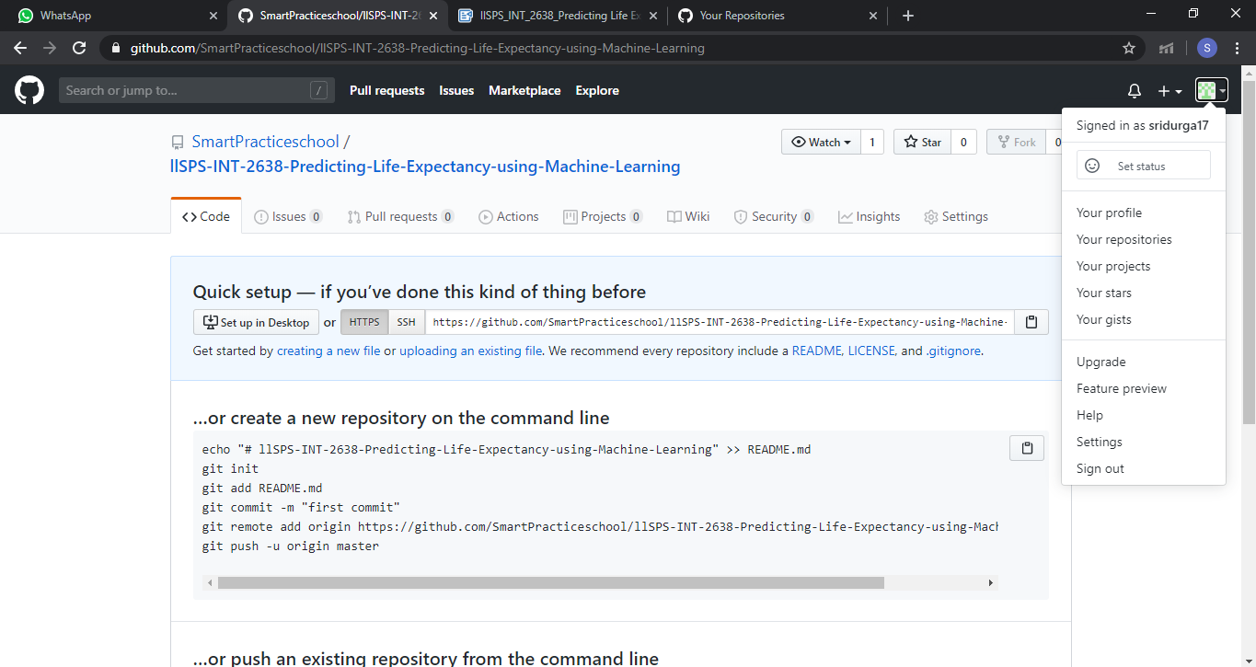

2.Slack Account:
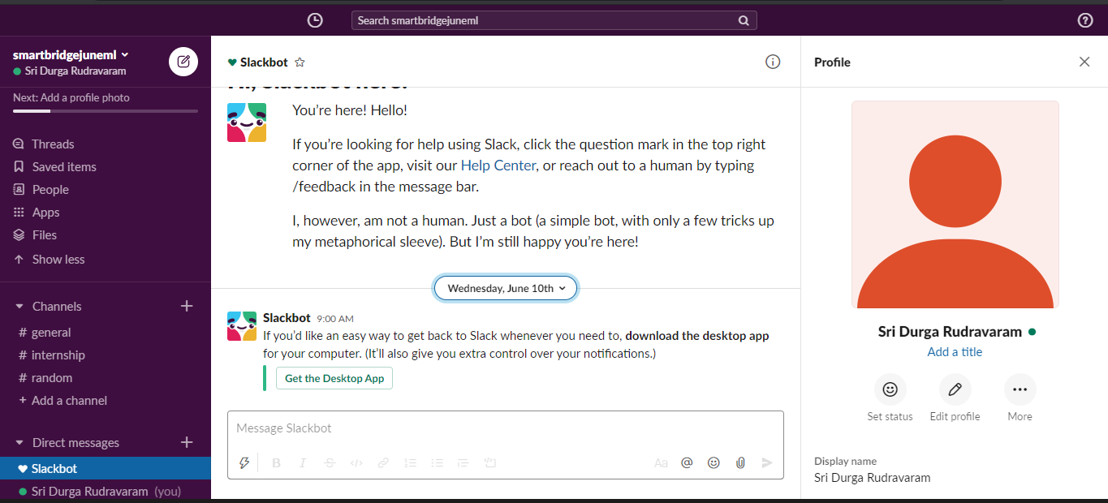

Exploring IBM Cloud Platform:
1.IBM Academic Initiative account:
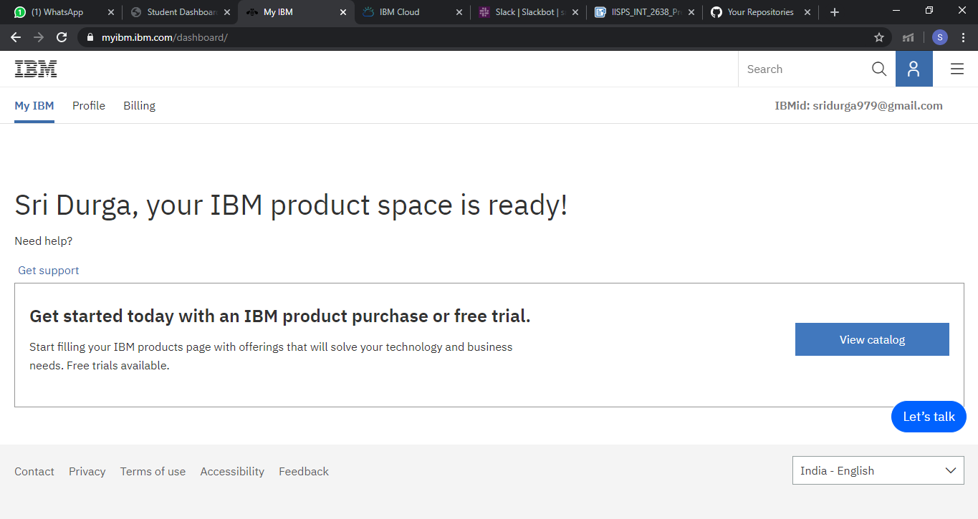

2.IBM Cloud account:
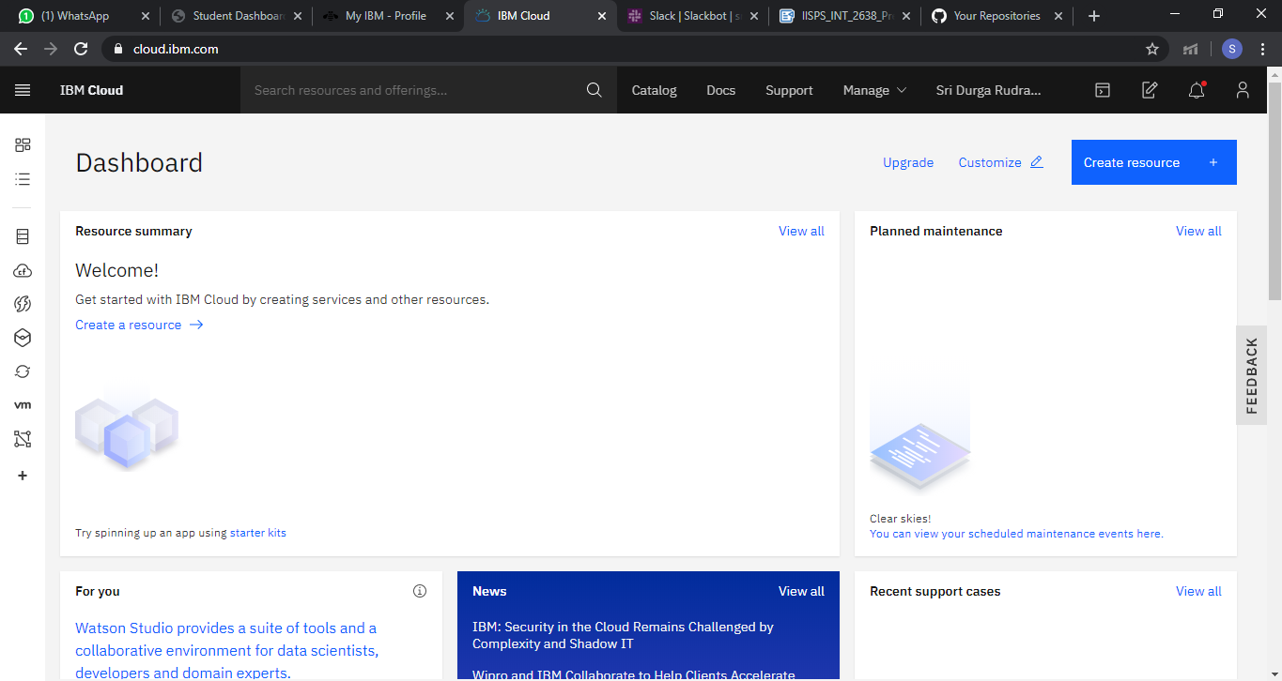
3.Node-Red starter application:
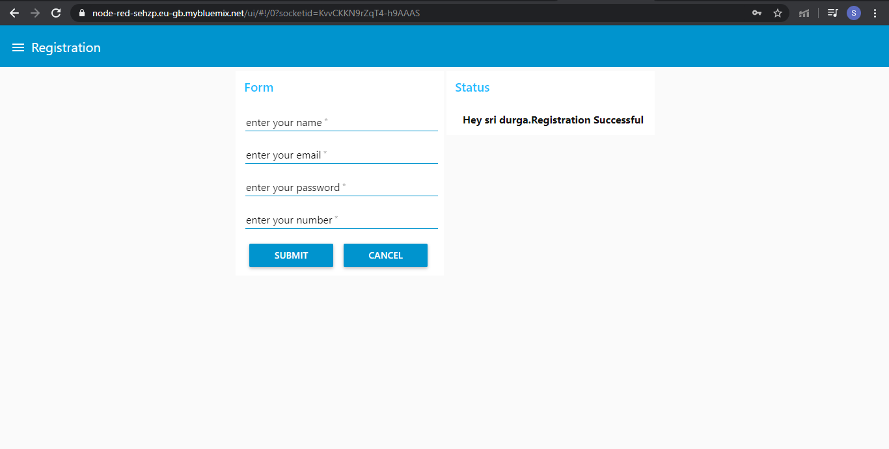Introduction to Watson Studio:
Building ML Model and Auto AI for sample data:
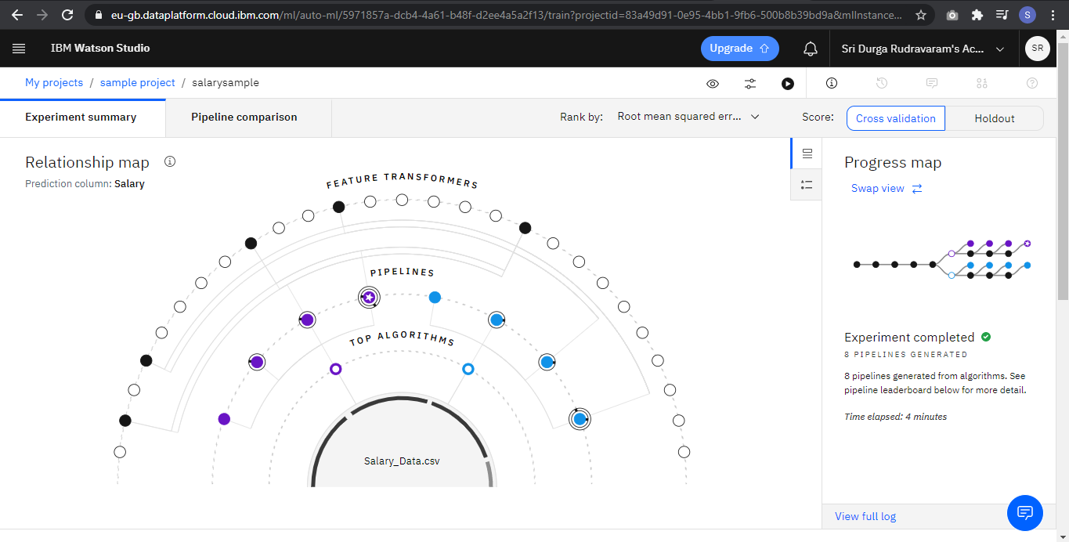

Node - red flow:
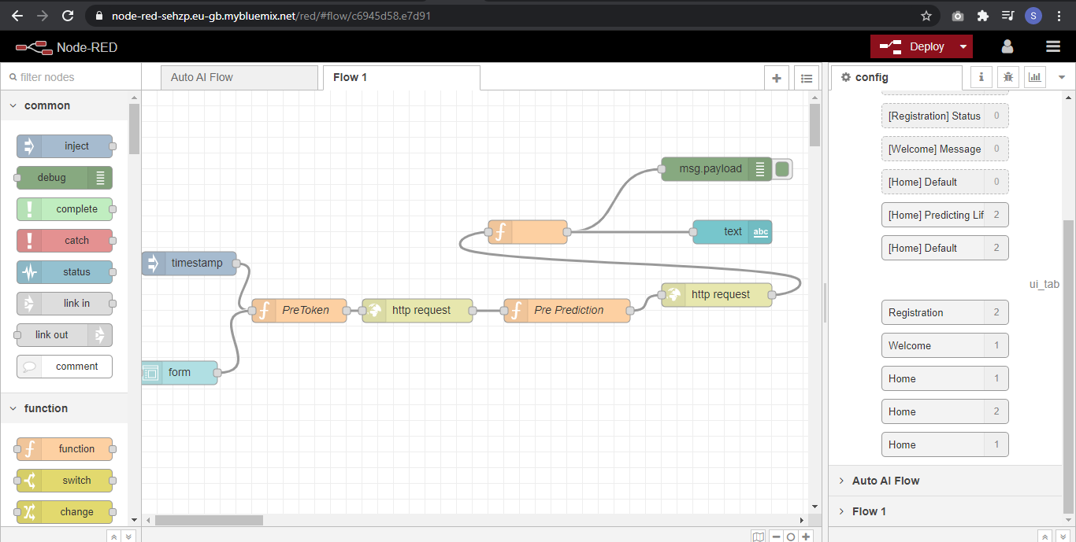
Predicting Life Expectency Without Python:
1.Collect the Dataset for the Project:
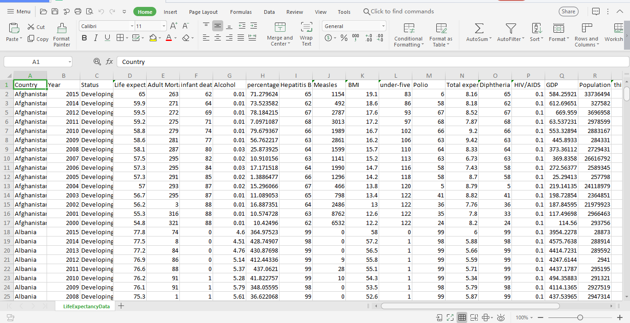

2.Create Necessary IBM Cloud Services:
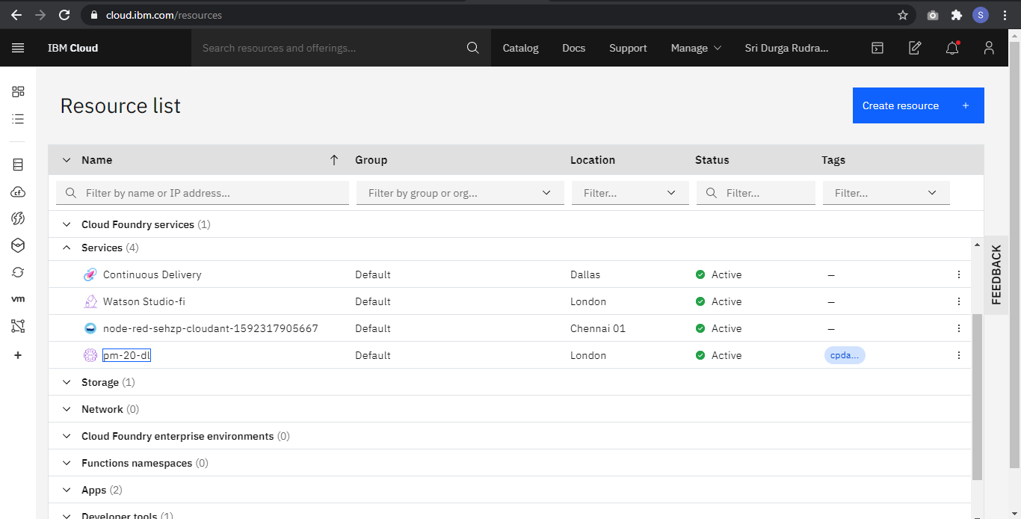

3.Create a Watson Studio Project:
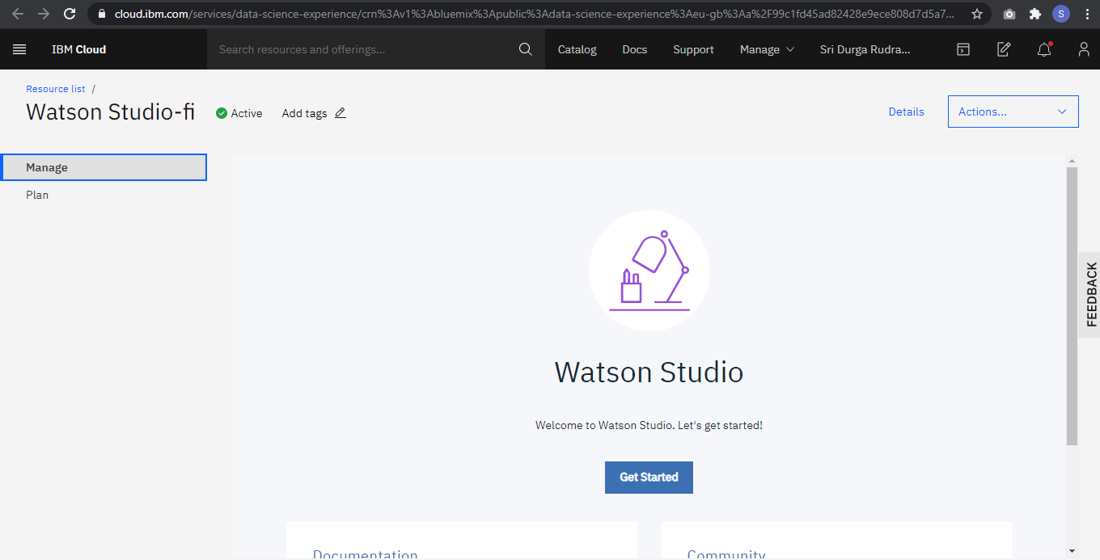

4.Create Machine Learning Service:
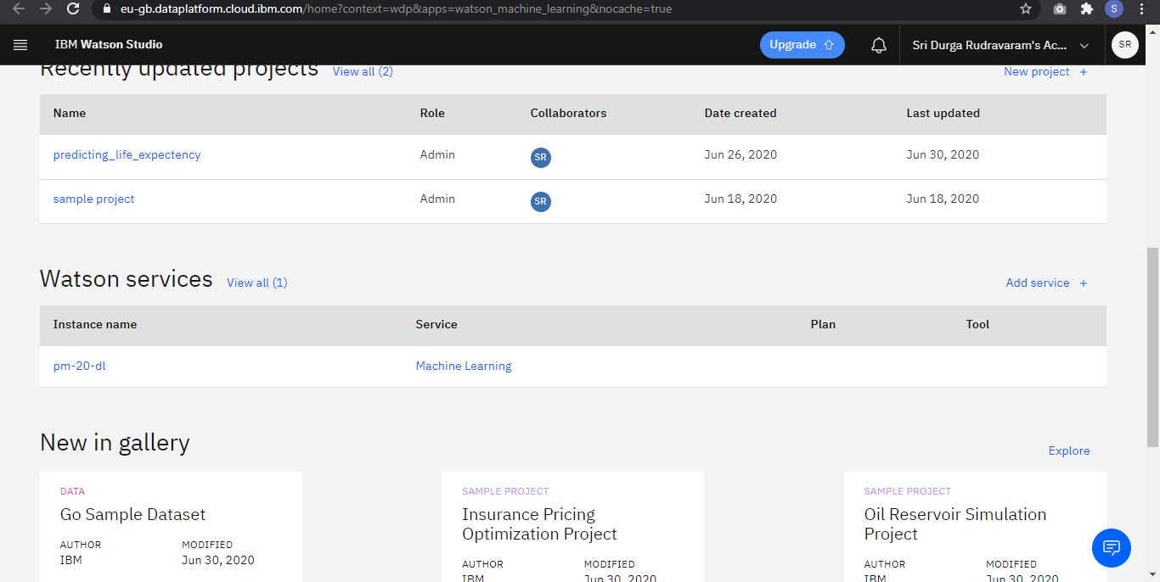

5.Import Dataset and Create AUTO AI Experiment:
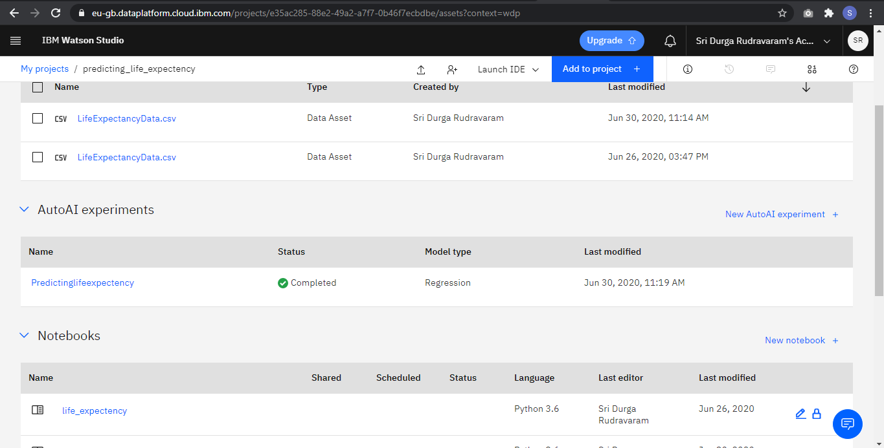

6.Build NODE-RED Flow to Integrate Auto AI:
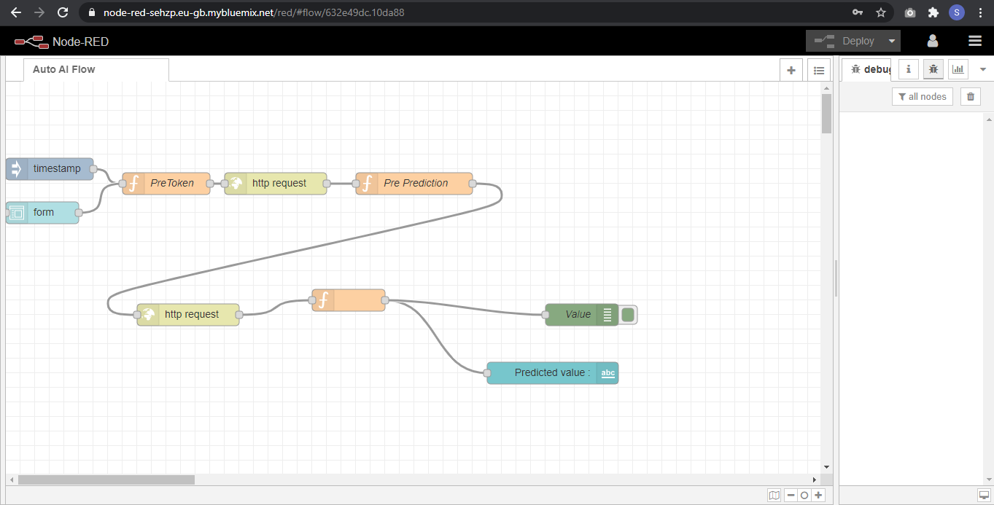

OUTPUT:
